Linear Predictive Coding Methods

Speech Processing
ECE 5525

Final Project Report

By: Mohamed M. Eljhani
Fall 2010

Problem Description

The main purpose of this project is to show the different between
three linear predictive methods by implementing a Matlab program that convert from a frame of speech to a set of linear Prediction coefficients, using three basic methods, i.e.

  - The Auto-correlation Method.
  - The Covariance Method.
  - The Lattice Filter Method.

Choose a section of a steady state vowel, and a section of unvoiced
speech, to plot LPC spectra from the three methods along with the
normal spectrum from the Hamming window weighted frame.

Write a MATLAB program to convert from a frame of speech to a set of linear prediction coefficients, using 3 methods, i.e., the Auto-correlation Method, the Covariance Method, and the Lattice Filter Method. Choose a section of a steady state vowel, and a section of unvoiced speech, and plot LPC spectra from the 3 methods along with the normal spectrum from the Hamming window weighted frame.
Use N = 300, p = 12, with Hamming Window weighting for the autocorrelation method. Use the same parameters for the Covariance and Lattice Methods. Use the files ah.wav to get a vowel steady state sound beginning at sample 3000, and the file test 16k.wav to get
a fricative beginning at sample 3000. (Note that for the covariance and lattice methods, you also need to preserve p samples before the starting sample at n = 3000 for computing correlations, and error signals).

Problem Solution

The following MATLAB program reads in a file of speech and computes the original spectrum (of the signal weighted by a Hamming window), and plots on top of this the LPC spectrum from the autocorrelation, covariance, and lattice methods. There is a main program and three functions (durbin for the auto-correlation method, cholesky for the covariance method although simple matrix inversion was used, rather than the Cholesky decomposition, and lattice for the traditional lattice method).

%
% read in speech file, chooses section of speech and solve for set of
% lpc coefficients using the autocorrelation method, the covariance
% method and the lattice method
%
% plot the resulting spectra from all three methods
%
% read in waveform for a speech file
%
% [xin,fs,mode,format]=loadwav('ah_truncated.wav');xin)
filename=input ('enter speech filename:','s');
[xin,fs,mode,format]=loadwav(filename);

% normalize input to [-1,1] range and play out sound file
xinn=xin/max(xin);
sound(xinn,fs);
[nrows ncol]=size(xin);
m=input('starting sample for speech frame:');
N=input('frame duration:');
p=input('lpc order:');
wtype=input(window type(1=Hamming, 0=Rectangular):);
stitle=sprintf('file: %s, ss: %d N: %d p: %d',filename,m,N,p);

% print out number of samples in file, read in plotting parameters
fprintf(' number of samples in file: %7.0f \n', nrows);

% autocorrelation method--choose section of speech, window using Hamming
% window, compute autocorrelation for i=0,1,...,p
% get original spectrum
xino=[(xin(m:m+N-1).*hamming(N))' zeros(1,512-N)];
h0=fft(xino,512);
f=0:fs/512:fs-fs/512;
plot(f(1:257),20*log10(abs(h0(1:257)))),title(stitle),ylabel('log magnitude (dB)'),...
xlabel('frequency in Hz');
hold on;

% autocorrelation method
xf=xin(m:m+N-1);
[R,E,k,alpha,G]=durbin(xf,N,p,wtype);
alphap=alpha(1:p,p);
num=[1 -alphap'];
[ha,f]=freqz(G,num,512,fs);
plot(f,20*log10(abs(ha)),'k-');

% fvtool(G,num);
% covariance method--choose section of speech, compute correlation matrix
% and covariance vector
xc=xin(m-p:m+N-1);
[phim,phiv,EC,alphac,GC]=cholesky(xc,N,p);
numc=[1 -alphac'];
[hc,f]=freqz(GC,numc,512,fs);
plot(f,20*log10(abs(hc)),'g--');

% fvtool(GC,numc);
% lattice method--choose section of speech, compute forward and backward
% errors
xl=xin(m-p:m+N-1);
[EL,alphal,GL,k]=lattice(xl,N,p);
alphalat=alphal(:,p);
numl=[1 -alphalat'];
[hl,f]=freqz(GL,numl,512,fs);
plot(f,20*log10(abs(hl)),'r-.');
legend('windowed speech','autocorrelation method(-)','covariance method(--)','lattice me% fvtool(GL,numl);
function [R,E,k,alpha,G]=durbin(xf,N,p,wtype)

% function [R,E,k,alpha,G]=durbin(xf,N,p,wtype)
%
% compute window based on wtype; wtype=1 for Hamming window, wtype=0 for
% Rectangular window
%
% compute R(0:p) from windowed xf
%
% solve Durbin recursion fo E,k,alpha in 8 easy steps
% step 1--E(0)=R(0)
% step 2--k(1)=R(1)/E(0)
% step 3--alpha(1,1)=k(1)
% step 4--E(1)=(1-k(1).^2)E(0)
% steps 5-8--for i=2,3,...,p;
% step 5--k(i)=[R(i)-sum from j=1 to i-1 alpha(j,i-1).*R(i-j)]/E(i-1)
% step 6--alpha(i,i)=k(i)
% step 7--for j=1,2,...,i-1
% alpha(j,i)=alpha(j,i-1)-k(i)alpha(i-j,i-1)
% step 8--E(i)=(1-k(i).^2)E(i-1)
%
if wtype==1
win=hamming(N);
else
win=boxcar(N);
end

% window frame for autocorrelation method
xf=xf.*win;
% compute autocorrelation
for k=0:p
R(k+1)=sum(xf(1:N-k).*xf(k+1:N));
end

% solve for lpc coefficients using Durbin's method
E=zeros(1,p);
k=zeros(1,p);
alpha=zeros(p,p);
E(1)=R(1);
ind=1;
k(ind)=R(ind+1)/E(ind);
alpha(ind,ind)=k(ind);
E(ind+1)=(1-k(ind).^2)*E(ind);
for ind=2:p
k(ind)=(R(ind+1)-sum(alpha(1:ind-1,ind-1)'.*R(ind:-1:2)))/E(ind);
alpha(ind,ind)=k(ind);
for jnd=1:ind-1
alpha(jnd,ind)=alpha(jnd,ind-1)-k(ind)*alpha(ind-jnd,ind-1);
end
E(ind+1)=(1-k(ind).^2)*E(ind);
end
G=sqrt(E(p+1));

function [phim,phiv,EC,alphac,GC]=cholesky(xc,N,p)
% cholesky decomposition
%
% first compute phim(1,1)...phim(p,p)
% next compute phiv(1,0)...phiv(p,0)
%
for i=1:p
for k=1:p
phim(i,k)=sum(xc(p+1-i:p+N-i).*xc(p+1-k:p+N-k));
end
end
for i=1:p
phiv(i)=sum(xc(p+1-i:p+N-i).*xc(p+1:p+N));
phiz(i)=sum(xc(p+1:p+N).*xc(p+1-i:p+N-i));
end
phi0=sum(xc(p+1:p+N).^2);

% use simple matrix inverse to solve equations--come back to Cholesky decomposition later
phiv=phiv';
% solve using matrix inverse, phim*alphac=phiv
% alphac=inv(phim)*phiv
%
alphac=inv(phim)*phiv;
EC=phi0-sum(alphac'.*phiz);
GC=sqrt(EC);

function [EL,alphal,GL,k]=lattice(xc,N,p)
% lattice solution to lpc equations
%
% follow 10 step solution
% step 1--set e(0)(m)=b(0)(m)=s(m)
% step 2--compute k1=alpha(1,1) from basic lattice reflection coefficient
% equation 8.89
% step 3--determine forward and backward errors e(1)(m) and b(1)(m) from
% eqns 8.84 and 8.87
% step 4--set i=2
% step 5--determine ki=alpha(i,i) from eqn 8.89
% step 6--determine alpha(j,i) for j-1,2,...,i-1 from eqn 8.70
% step 7--determine e(i)(m) and b(i)(m) from eqns. 8.84 and 8.87
% step 8--set i=i+1
% step 9--if i<=p, go to step 5
% step 10--finished
e(:,1)=xc;
b(:,1)=xc;
k(1)=sum(e(p+1:p+N,1).*b(p:p+N-1,1))/sqrt((sum(e(p+1:p+N,1).^2)*sum(b(p:p+N-1,1).^2)));
alphal(1,1)=k(1);
btemp=[0 b(:,1)']';
e(1:N+p,2)=e(1:N+p,1)-k(1)*btemp(1:N+p);
b(1:N+p,2)=btemp(1:N+p)-k(1)*e(1:N+p,1);
for i=2:p
k(i)=sum(e(p+1:p+N,i).*b(p:p+N-1,i))/sqrt((sum(e(p+1:p+N,i).^2)*sum(b(p:p+N-1,i).^2)alphal(i,i)=k(i);
for j=1:i-1
alphal(j,i)=alphal(j,i-1)-k(i)*alphal(i-j,i-1);
end
btemp=[0 b(:,i)']';
e(1:N+p,i+1)=e(1:N+p,i)-k(i)*btemp(1:N+p);
b(1:N+p,i+1)=btemp(1:N+p)-k(i)*e(1:N+p,i);
end
EL=sum(xc(p+1:p+N).^2);
for i=1:p
EL=EL*(1-k(i).^2);
end
GL=sqrt(EL);

The following plots are for a vowel from the file ah.wav, and a fricative from the file test 16k.wav.

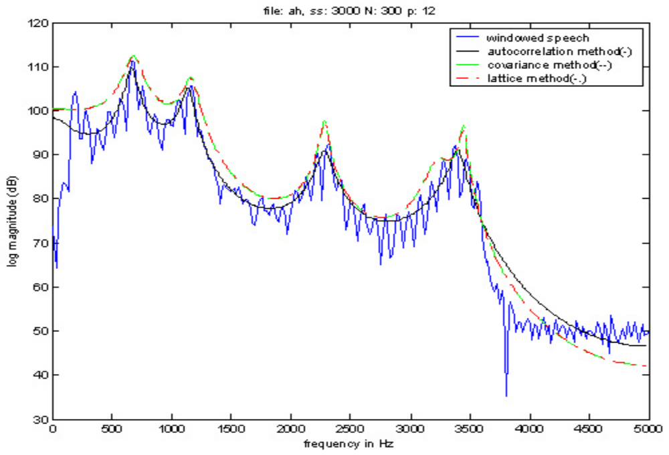

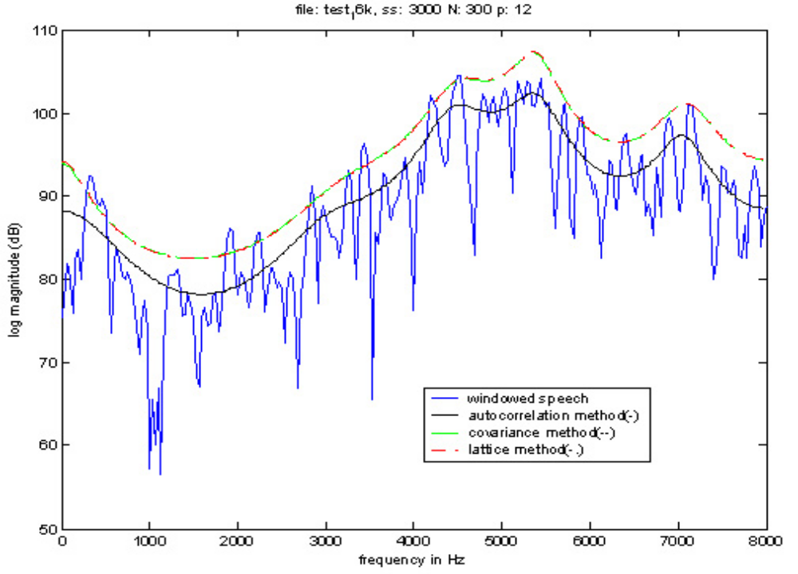

Introduction

There exist many different types of speech compression that make use of a variety of different techniques. However, most methods of speech compression exploit the fact that speech production occurs through slow anatomical movements and that the speech produced has a limited frequency range. The frequency of human speech production ranges from around 300 Hz to 3400 Hz. Speech compression is often referred to as speech coding which is defined as a method for reducing the amount of information needed to represent a speech signal. Most forms of speech coding are usually based on a lossy algorithm. Lossy algorithms are considered acceptable when encoding speech because the loss of quality is often undetectable to the human ear. There are many other characteristics about speech production that can be exploited by speech coding algorithms. One fact that is often used is that period of silence take up greater than 50% of conversations. An easy way to save bandwidth and reduce the amount of information needed to represent the speech signal is to not transmit the silence. Another fact about speech production that can be taken advantage of is that mechanically there is a high correlation between adjacent samples of speech. Most forms of speech compression are achieved by modeling the process of speech production as a linear digital filter. The digital filter and its slow changing parameters are usually encoded to achieve compression from the speech signal. Linear Predictive Coding (LPC) is one of the methods of compression that models the process of speech production. Specifically, LPC models this process as a linear sum of earlier samples using a digital filter inputting an excitement signal. An alternate explanation is that linear prediction filters attempt to predict future values of the input signal based on past signals. LPC “...models speech as an autoregressive process, and sends the parameters of the process as opposed to sending the speech
itself”. It was first proposed as a method for encoding human speech by the United States Department of Defense in federal standard 1015, published in 1984. Another name for federal standard 1015 is LPC-10 which is the method of linear predictive coding.

Speech coding or compression is usually conducted with the use of voice coders or vocoders. There are two types of voice coders: waveform-following coders and model-base coders.
Wave form following coders will exactly reproduce the original speech signal if no quantization errors occur. Model-based coders will never exactly reproduce the original speech signal, regardless of the presence of quantization errors, because they use a parametric model

of speech production which involves encoding and transmitting the parameters not the signal. LPC vocoders are considered model-based coders which means that LPC coding is lossy even if no quantization errors occur. All vocoders, including LPC vocoders, have four main attributes: bit rate, delay, complexity, quality. Any voice coder, regardless of the algorithm it uses, will have to make trade offs between these different attributes. The first attribute of vocoders, the bit rate, is used to determine the degree of compression that a vocoder achieves. Uncompressed speech is usually transmitted at 64 kb/s using 8 bits/sample and a rate of 8 kHz for sampling. Any bit rate below 64 kb/s is considered compression. The linear predictive coder transmits speech at a bit rate of 2.4 kb/s, an excellent rate of compression. Delay is another important attribute for vocoders that are involved with the transmission of an encoded speech signal. Vocoders which are involved with the storage of the compressed speech, as opposed to transmission, are not as concern with delay. The general delay standard for transmitted speech conversations is that any delay that is greater than 300 ms is considered unacceptable. The third attribute of voice coders is the complexity of the algorithm used. The complexity affects both the cost and the power of the vocoder. Linear predictive coding because of its high compression rate is very complex and involves executing millions of instructions per second. LPC often requires more than one processor to run in real time. The final attribute of vocoders is quality. Quality is a subjective attribute and it depends on how the speech sounds to a given listener. One of the most common test for speech quality is the absolute category rating (ACR) test. This test involves subjects being given pairs of sentences and asked to rate them as excellent, good, fair, poor, or bad. Linear predictive coders sacrifice quality in order to achieve a low bit rate and as a result often sound synthetic. An alternate method of speech compression called adaptive differential pulse code modulation (ADPCM) only reduces the bit rate by a factor of 2 to 4, between 16 kb/s and 32kb/s , but has a much higher quality of speech than LPC.

The general algorithm for linear predictive coding involves an analysis or encoding part and a synthesis or decoding part. In the encoding, LPC takes the speech signal in blocks or frames of speech and determines the input signal and the coefficients of the filter that will be capable of reproducing the current block of speech. This information is quantized and transmitted. In the decoding, LPC rebuilds the filter based on the coefficients received. The filter can be thought of as
a tube which, when given an input signal, attempts to output speech. Additional information about the original speech signal is used by the decoder to determine the input or excitation signal that is sent to the filter for synthesis.

LPC Model

The particular source-filter model used in LPC is known as the Linear predictive coding model. It has two key components: analysis or encoding and synthesis or decoding. The analysis part of LPC involves examining the speech signal and breaking it down into segments or blocks. Each segment is than examined further to find the answers to several key questions:
• Is the segment voiced or unvoiced?
• What is the pitch of the segment?
• What parameters are needed to build a filter that models the
Vocal tract for the current segment?

LPC analysis is usually conducted by a sender who answers these questions and usually transmits these answers onto a receiver. The receiver performs LPC synthesis by using the answers received
to build a filter that when provided the correct input source will be able to accurately reproduce the original speech signal. Essentially, LPC synthesis tries to imitate human speech production. Figure demonstrates what parts of the receiver correspond to what parts in the human anatomy. This diagram is for a general voice or speech coder and is not specific to linear predictive coding. All voice coders tend to model two things: excitation and articulation. Excitation is the type of sound that is passed into the filter or vocal tract and articulation is the transformation of the excitation signal into speech.
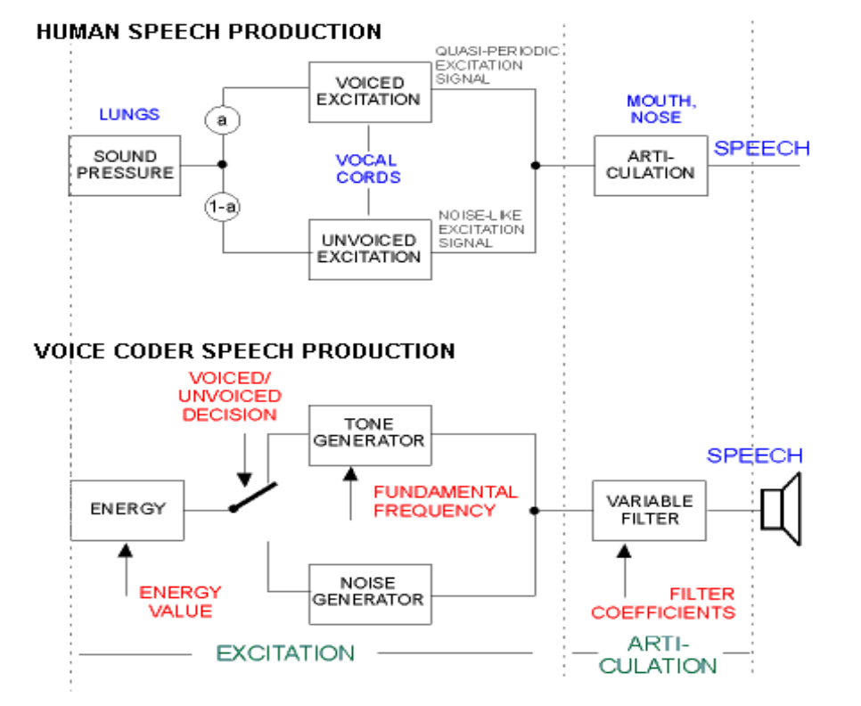

LPC Methods

• LPC methods are the most widely used in speech coding, speech
synthesis, speech recognition, speaker recognition and verification
and for speech storage.

– LPC methods provide extremely accurate estimates of speech
parameters, and does it extremely efficiently.

– basic idea of Linear Prediction: current speech sample can be
closely approximated as a linear combination of past samples,
i.e.

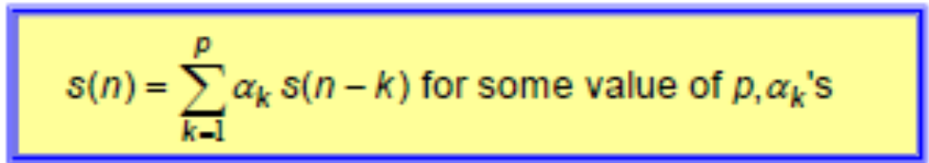

• LP methods have been used in control and information theory—
called methods of system estimation and system identification
– used extensively in speech under group of names including
1. covariance method
2. autocorrelation method
3. lattice method
4. inverse filter formulation
5. spectral estimation formulation
6. maximum likelihood method
7. inner product method

LPC Estimation Issues

• need to determine {αk} directly from speech such that they give
good estimates of the time-varying spectrum

• need to estimate {αk} from short segments of speech

• need to minimize mean-squared prediction error over short
segments of speech

• resulting {αk} assumed to be the actual {ak} in the speech
production model
=> intend to show that all of this can be done efficiently,
reliably, and accurately for speech

Autocorrelation Method

- assume S^n (m) exists for 0 ≤ m ≤ L-1 and is exactly zero everywhere else (i.e., window of length L samples)

- Where w(m) is a finite length window of length L samples



- if S^n (m) is non-zero only for 0 ≤ m ≤ L-1 then

is non-zero only over the interval 0 ≤ m ≤ L-1 + p

- at values of m near 0 (i.e., m = 0,1,…..,p-1) we are predicting signal from zero-valued samples (outside the window range)
=> e^n (m) will be (relatively) large
- at values near m = L (i.e., m = L,L+1,……,L+p-1) we are predicting zero-valued samples (outside the window range) from non-zero samples => e^n (m) will be (relatively) large
- for these reasons, normally use windows that taper the segment to zero (e.g., Hamming window)



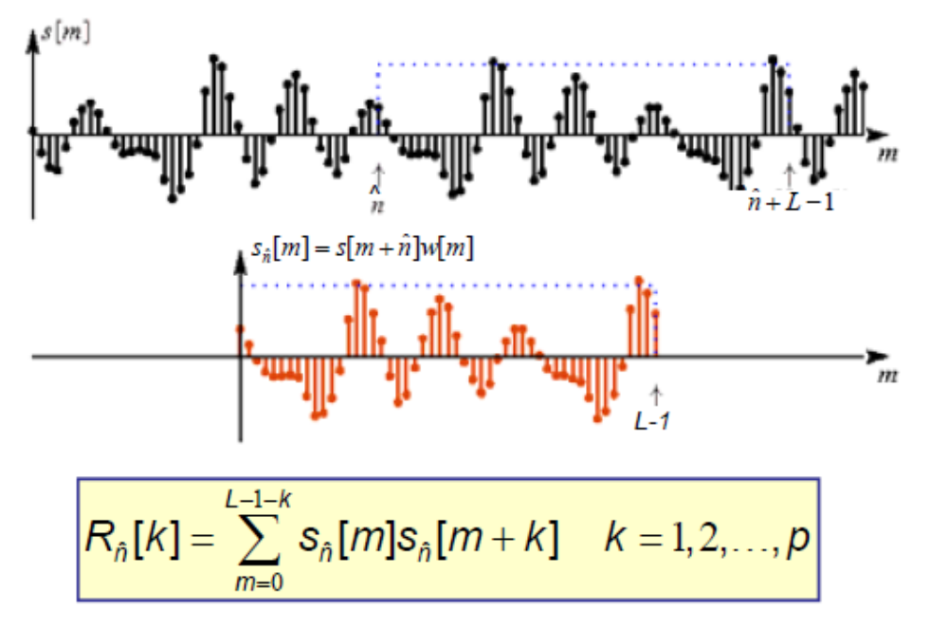

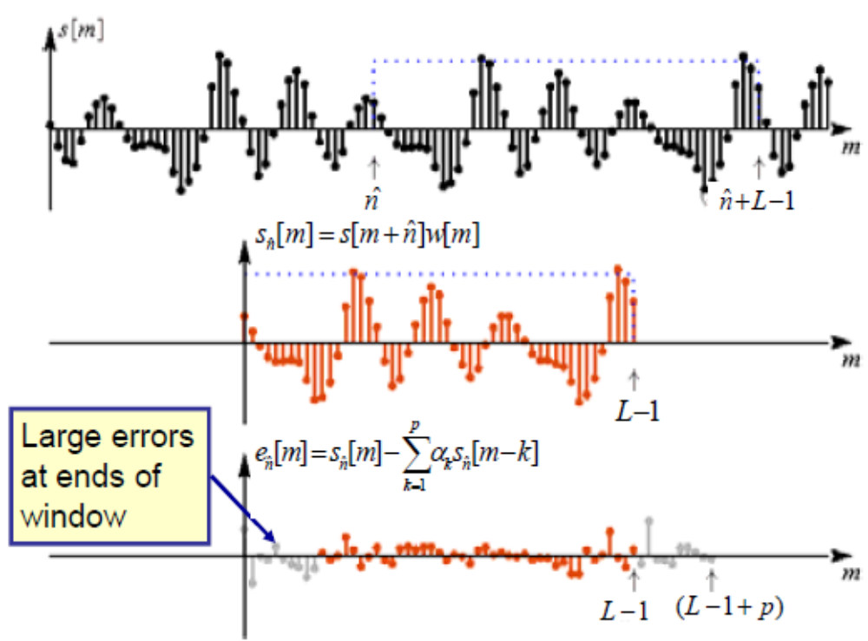

Covariance Method

Covariance is a second basic approach to defining the speech
segment S^n (m) and the limits on the sums, namely fix the interval
over which the mean-squared error is computed, giving

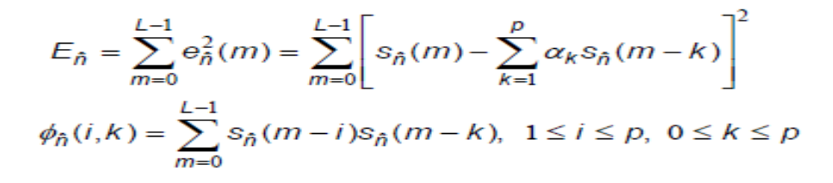

- Changing the summation index gives

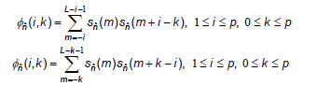

- Key difference from Autocorrelation Method is that limits of summation include terms before m=0
=>window extends p samples backwards from

- Since we are extending window backwards, don’t need to taper it using a HW- since there is no transition at window edges

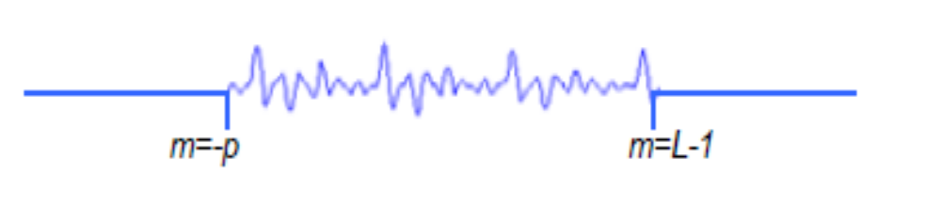
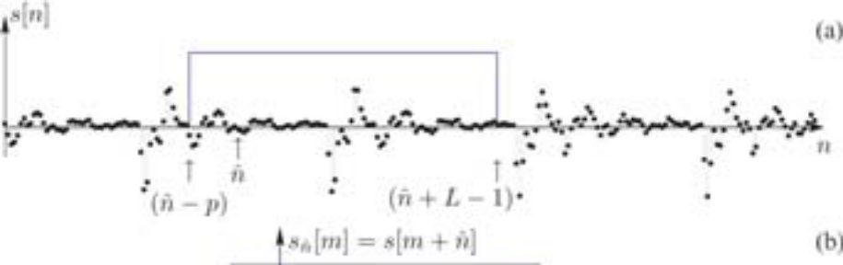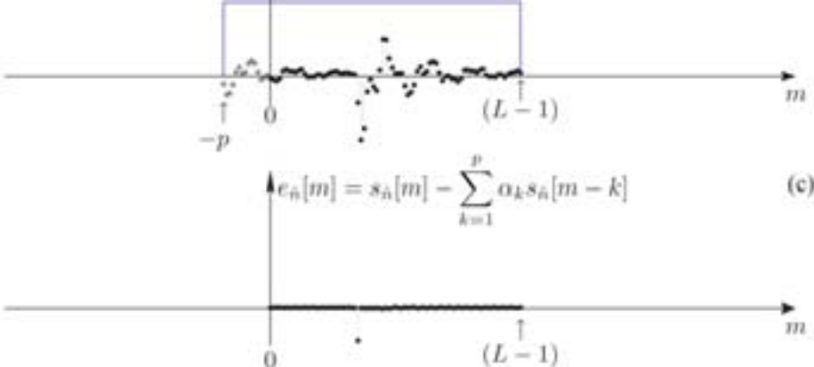

Autocorrelation/Covariance Summary

- Use order linear predictor to predict from p previous samples
- Minimize mean-square error 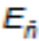 over analysis window of duration
L-samples
- Solution for optimum predictor coefficients 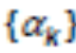 is based on solving a matrix equation
=> two solution have evolved

1. Autocorrelation Method => signal is windowed by a tapering
window in order to minimize discontinuities at beginning
(predicting speech from zero-valued samples) and end
(predicting zero-valued samples from speech samples) of the
interval; the matrix 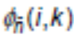 is shown to be an
autocorrelation function, the resulting autocorrelation matrix can
be readily solved using standard matrix solutions

2. Covariance method => the signal is extended by p samples
outside the normal range of to include p
samples occurring prior to m=0 (they are available) and
eliminates the need for a tapering window; resulting matrix of
correlations is symmetric
  - different method of solution with somewhat different set of optimal prediction coefficients,

Lattice Method

- both covariance and autocorrelation methods use two step
solutions
1. computation of a matrix of correlation values
2. efficient solution of a set of linear equations

- another class of LP methods called lattice methods, has
evolved in which the two steps are combined into a recursive
algorithm for determining LP parameters

- begin with Durbin algorithm--at the i th stage the set of
coefficients 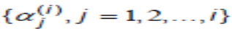 are coefficients of the i th order
optimum LP

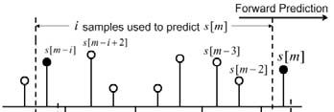
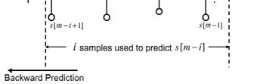
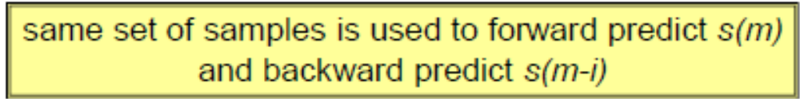

Final Problem Solution

The following MATLAB program LPC Matlab Files\test_lpc.m reads in a file of speech and computes The original spectrum (of the signal
weighted by a Hamming window), and plots on top of this the LPC
spectrum from the
  - Autocorrelation method
  - Covariance method
  - lattice method
There is a main program and 3 functions
1. Durbin for the auto-correlation method,
LPC Matlab Files\durbin.m
2. cholesky for the covariance method although simple matrix
inversion was used, rather than the Cholesky
decomposition, LPC Matlab Files\cholesky_full.m
3. lattice for the traditional lattice method,
LPC Matlab Files\lattice.m

LPC Matlab Files\autolpc.m is used to generate lpc parameters.

LPC Comparisons

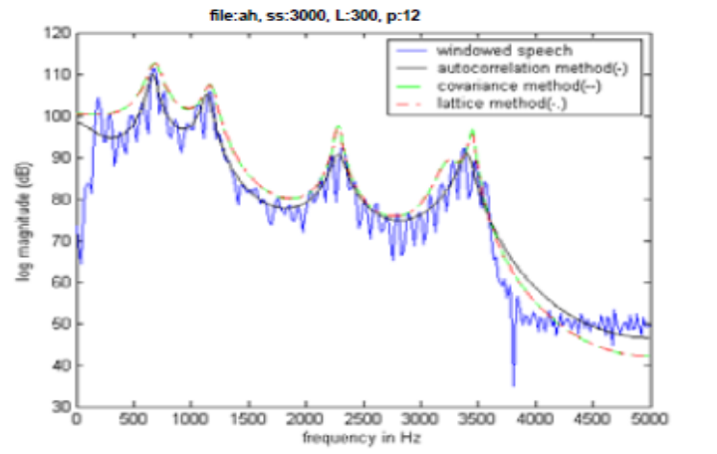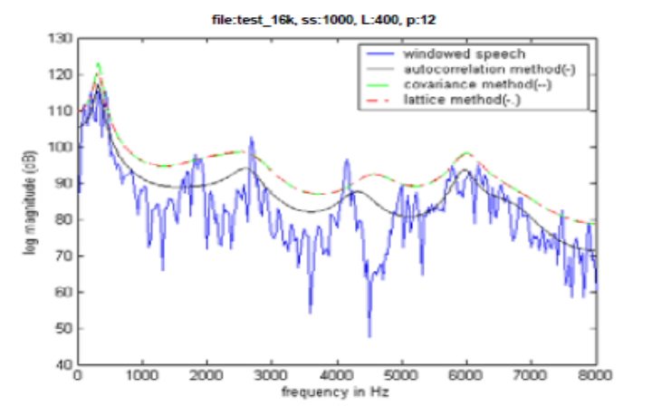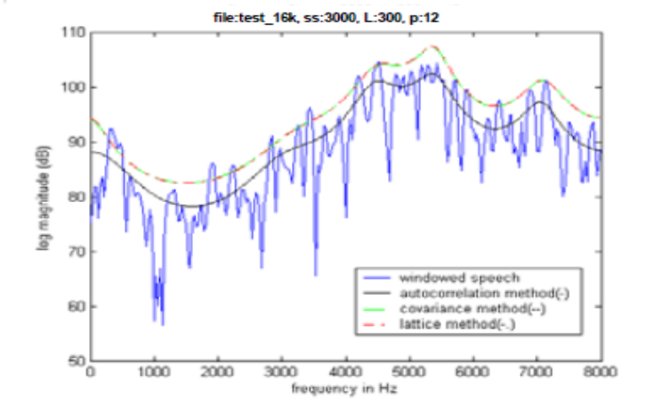

LPC Computations

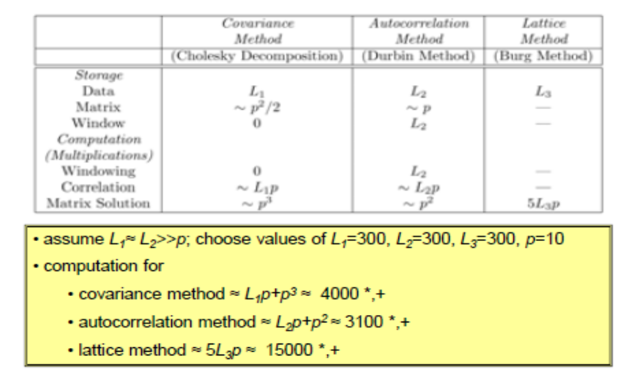

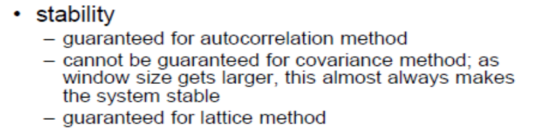

Conclusion

- Linear Predictive Coding is an analysis/synthesis technique to
lossy speech compression that attempts to model the human
production of sound instead of transmitting an estimate of the
sound wave.
- Linear predictive coding break up a sound signal into
different segments and then send information on each segment
to the decoder. The encoder send information on whether the
segment is voiced or unvoiced and the pitch period for voiced
segment which is used to create an excitement signal in the
decoder. The encoder also sends information about the vocal
tract which is used to build a filter on the decoder side which
when given the excitement signal as input can reproduce the
original speech.

Bibliography & References

- Lawrence Rabiner Rutgers University, Dept. of Electrical and Computer Engineering
Course Website: www.caip.rutgers.edu/~lrr.
being changed to cronos.rutgers.edu/~lrr.

- L. R. Rabiner and R. W. Schafer, Theory and Applications of Digital Speech Processing, Prentice-Hall Inc., 2010.

- Linear Predictive Coding, Jeremy Bradbury, December 5, 2000.

